[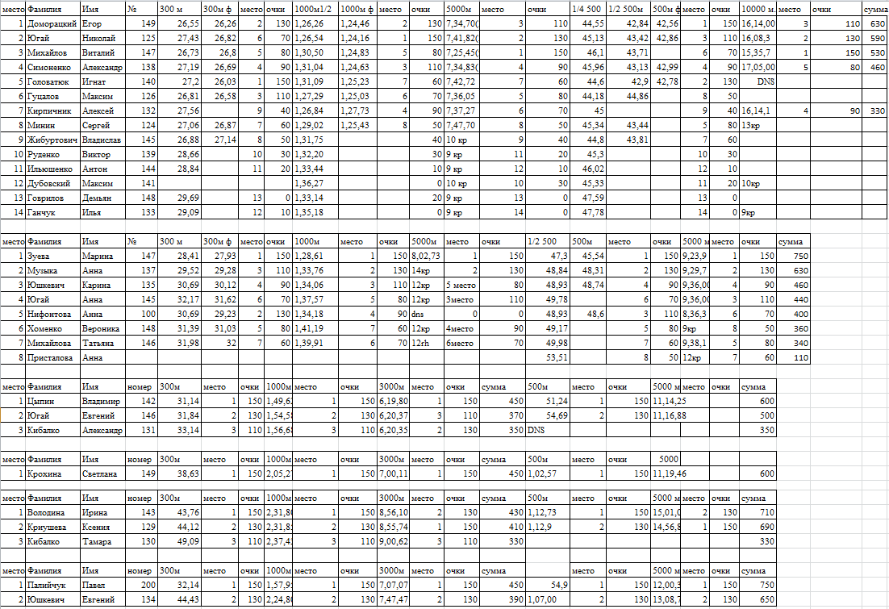](https://www.proskating.by/sites/default/files/rezultaty_1.png)

[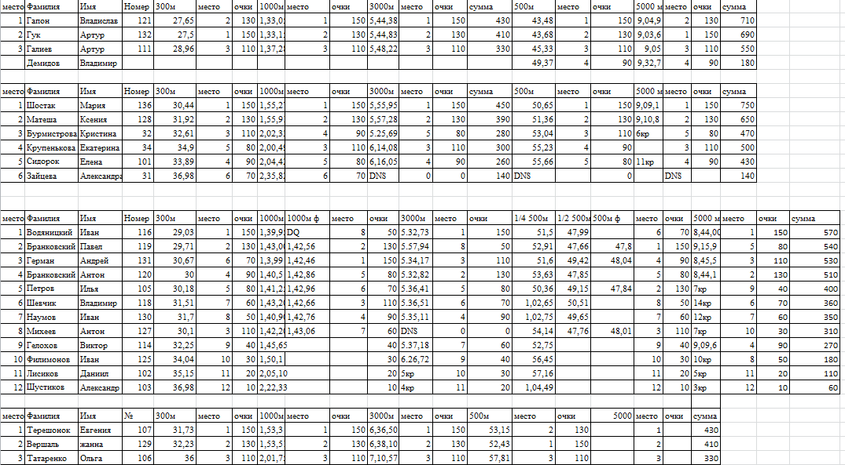](https://www.proskating.by/sites/default/files/rezultaty_2.png)

[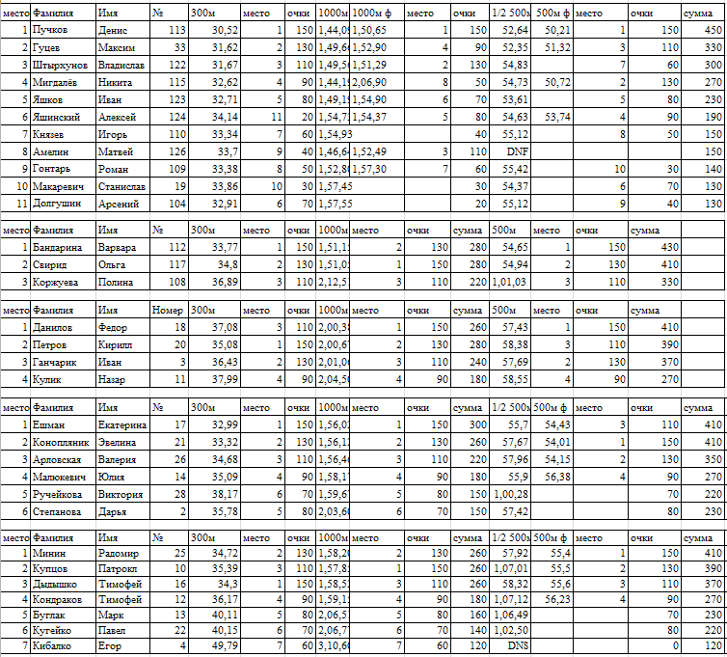](https://www.proskating.by/sites/default/files/rezultaty_3.png)

[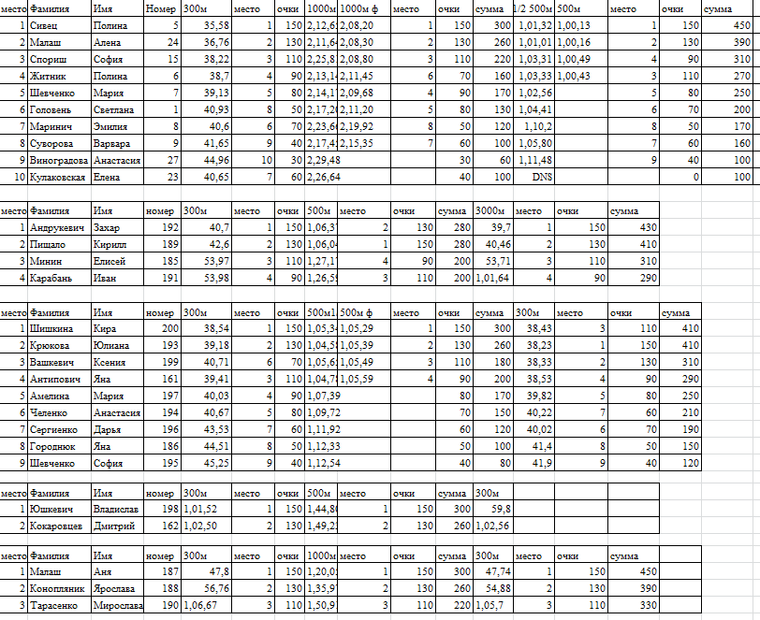](https://www.proskating.by/sites/default/files/rezultaty_4.png)

[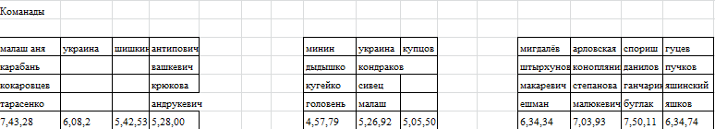](https://www.proskating.by/sites/default/files/rezultaty_5.png)